| Course name | Numerical Modeling & Simulation in Scilab Xcos |
| --- | --- |
| **Lesson name** | **Numerical Modelling of Nissan Leaf using WLTP Drive Cycle data in Scilab-Xcos** |
| **Lesson objective** | **Practice blocks &** **acquaint to use GUI of Scilab-Xcos** |
| Created by | Bharath Kumar P |

**Problem statement:** Model Nissan Leaf for WLTP Drive Cycle in Scilab Xcos to plot the Wheel Torque, Wheel Speed, Motor Torque, Motor Speed and Battery Current in Scilab-Xcos.

**WLTP Drive Cycle Graph:**

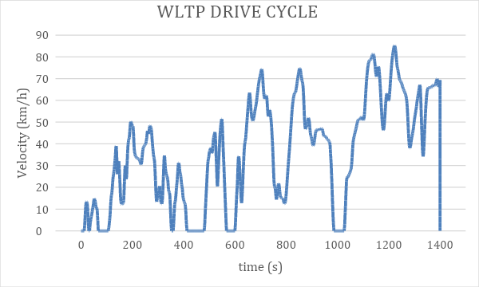

**Model Inputs:**

| **Sl No** | **Parameter** | **Value** | **Units** |
| --- | --- | --- | --- |
|  | **Chassis** |  |  |
|  | 1. Coefficient of rolling resistance | 0.015 |  |
|  | 1. Mass of Vehicle | 1630.665 | Kg |
|  | 1. Mass of Driver | 80 | Kg |
|  | 1. Gravity constant | 9.81 | m/s |
|  | 1. Grade Angle | 0 | degree |
|  | 1. Velocity | From the WLTP Drive Cycle data | Kmph |
|  | 1. Frontal Area | 3.8056 | m^2 |
|  | 1. Air Density | 1.225 | Kg/m^3 |
|  | 1. Drag Coefficient | 0.28 |  |
|  | 1. Radius of wheel | 0.2032 | m |
|  | **Transmission** |  |  |
|  | 1. Gear Ratio | 7.9377 |  |
|  | 1. Transmission Efficiency | 89 | % |
|  | **Motor** |  |  |
|  | Motor Efficiency | 92 | % |
|  | **Battery** |  |  |
|  | 1. Motor Controller Efficiency | 90 | % |
|  | 1. Battery Capacity | 24000 | Wh |
|  | 1. Battery Voltage | 364.8 | V |
|  | 1. WLTP drive cycle distance | 14.664 | Km |
|  | 1. Battery Initial SOC | 100 | % |
|  | 1. Drive Cycle time or Simulation time | 1477 | s |
|  | **Cell** |  |  |
|  | 1. Cell Voltage | 3.8 | V |
|  | 1. Cell Capacity | 33.1 | Ah |